Detection of hateful and offensive tweets using deep learning

Team Members

Kovida Munnangi (Roll No:- AP22111260002)
Hema Lalitha Ponnekanti (Roll No:- AP22111260025)
Deepak Kumar Tathapudi (Roll No:- AP22111260031)

Supervisor: Dr. Vivek Yelleti
Department of Computer Science and Engineering
SRM University AP

ABSTRACT

With rapid growth in user-generated content and usage of multiple languages within a single platform, hate speech on social media has become one of the major challenges. Multilingual and code-mixed tweets abound in Twitter, hence making automatic hate speech detection more complicated. This project endeavors to construct an effective machine learning-based system capable of detecting hate speech in English, Telugu, and Hindi tweets.
Three publicly available datasets were gathered, cleaned, and combined for each language to develop a balanced multilingual dataset. Text preprocessing was done through techniques like tokenization, stopword removal, and normalization to prepare the data for model training. A TF-IDF vectorization pipeline combined with Logistic Regression because of its simplicity and robust performance in text classification tasks serves as a baseline model. The model is then trained and evaluated based on its accuracy, precision, recall, and F1-score to ensure that hate-related content is reliably detected.
The system shows strong results for all languages, which indicates that it generalizes well even with code-mixed data. This work contributes to safer online communication by enabling the scalable detection of harmful content. The project also underlines the relevance of multilingually balanced datasets and forms the basis for further extensions using more advanced deep learning and transformer-based methods.

INTRODUCTION

Social media platforms have emerged over the past couple of decades as a core platform for global communication, allowing millions of users to share their opinions, express their emotions, and engage in public debate. While these platforms revolutionized digital communication, they concurrently created fertile breeding grounds for hate speech, harassment, cyberbullying, and abusive language. Hate speech on the internet carries serious psychological, social, and even political repercussions when directed against vulnerable communities.

Therefore, the detection and mitigation of hate speech has emerged as a crucial research problem in NLP.
Motivation
This work is motivated by the rapid growth in the volume of multilingual and code-mixed content on Indian social media platforms. Users frequently express opinions in combinations such as English, Hindi, Telugu, and other regional languages, which makes traditional methods of hate speech detection ineffective. Apart from that, the dynamic and unstructured nature of tweets often includes slang, abbreviations, emojis, and sarcasm, which complicates the detection.
Social media tools currently use either rule-based moderation methods or depend greatly on human reporting. Both methods are considered quite inadequate because of:
- The sheer scale of user-generated content.
- Language diversity in multilingual countries. Emerging forms of hate expression include coded language.
- Lack of Interpretability in automated moderation tools.
This means that developing an automated, scalable, accurate, and explainable system of hate speech detection is crucial for maintaining safer online environments.
Current Best-Known Approaches
Hate speech detection has evolved significantly over the past decade, and several approaches have been widely used in research and industry. The early generation of systems relied heavily on rule-based methods, where manually defined keywords or offensive lexicons were used to identify hateful expressions. Although easy to implement, these systems struggled with ambiguity, sarcasm, and changes in language patterns.
To overcome these limitations, researchers shifted to traditional machine learning classifiers. Models such as Logistic Regression, Naïve Bayes, Support Vector Machines (SVM), and Random Forests became popular. These models typically used text representations such as:
- Bag-of-Words (BoW)
- TF-IDF features
- Character n-grams
- Basic sentiment indicators
These features helped capture surface-level linguistic cues. However, such approaches still lacked the ability to understand context, word order, and deeper semantics, making them less reliable for social media data.
The introduction of deep learning techniques marked a significant improvement in text classification tasks. Architectures like Convolutional Neural Networks (CNN) and Recurrent Neural Networks (RNN), especially Long Short-Term Memory (LSTM) networks, provided better semantic understanding by modeling sequences of words. CNNs excelled at detecting local patterns such as hateful phrases, while LSTMs captured long-range dependencies in text. Even so, these models depended on pre-trained word embeddings and sometimes struggled with noisy or code-mixed content.
In recent years, Transformer-based models have become the dominant approach for hate speech detection. Pre-trained models such as BERT, DistilBERT, RoBERTa, and XLM-RoBERTa leverage self-attention mechanisms to analyze the entire sentence structure simultaneously. These models provide:
- Context-aware word representations
- Strong performance with limited task-specific training
- Improved understanding of ambiguity and nuanced language
Transformers currently represent the best-performing class of models for text classification, including hate speech detection. However, they also introduce challenges such as high computational cost and a lack of transparency, as they generally behave like black-box systems.
These limitations motivate the need for improved multilingual handling, better interpretability, and more comprehensive evaluation — aspects that the proposed project addresses.

PROBLEM STATEMENT

With the rapid growth of social media platforms such as Twitter, online communication has become more accessible and widespread. However, this increased interaction has also led to a significant rise in hate speech, abusive language, and offensive content. Detecting such harmful text automatically is challenging due to several factors:
- The informal and unstructured nature of tweets.
- Frequent use of slang, abbreviations, emojis, and code-mixed text.
- Multilingual usage, especially in Indian social platforms.
- Context-dependent meaning that traditional machine learning models fail to capture.
- The absence of interpretability in deep learning and transformer-based systems.
Although several methods exist for hate speech classification, most of them are limited to English, rely on handcrafted features, and perform poorly on multilingual datasets. Current state-of-the-art transformer models achieve high accuracy but lack transparency, making it difficult to understand why a prediction was made.
Therefore, the core problem addressed in this project is:
To design and develop a multilingual hate speech detection system for Twitter using machine learning, deep learning, and transformer architectures, along with Explainable AI techniques, in order to achieve accurate and interpretable classification of hate and non-hate content.
This problem encompasses both the technical challenge of building robust classification models and the practical need for interpretability to support safe and trustworthy deployment.

NOVELTY CLAIMS

The proposed system introduces several novel contributions that differentiate it from existing hate speech detection methods. The key novelty elements are:
- Novelty 1: Multilingual Hate Speech Detection (English–Hindi–Telugu)
While most existing systems focus only on English data, the proposed method integrates three languages into a unified dataset. This enables efficient detection of hate speech in multilingual and code-mixed Indian social media environments, which is rarely addressed in prior research.

- Novelty 2: Unified Multi-Level Modeling Framework (ML → DL → Transformers)
Existing studies typically rely on a single modeling approach. This work systematically evaluates three tiers of models, traditional machine learning, deep learning architectures, and modern transformer models, offering a comprehensive comparative study for multilingual hate speech classification.

- Novelty 3: Application of HateBERT to Indian Social Media Data
HateBERT is pre-trained on abusive Reddit communities. This project uniquely evaluates its performance on Indian Twitter datasets, contributing new insights into cross-domain and cross-lingual model generalization.

- Novelty 4: Integration of Multiple Explainable AI Techniques
Most hate speech systems act as black-box models. This project incorporates three Explainable AI methods like LIME, SHAP, and Integrated Gradients, to interpret predictions at word and embedding levels, improving transparency and trustworthiness of automated moderation systems.

PROPOSED METHODOLOGY

The proposed methodology aims to build a robust multilingual hate speech detection system capable of classifying English, Hindi, and Telugu tweets as hate or non-hate using Machine Learning, Deep Learning, and Transformer-based models. The framework consists of six major components: Dataset Preparation, Preprocessing, Feature Extraction, Model Development, Explainable AI, and Evaluation. The methodology is structured to ensure scalability, interpretability, and high accuracy for real-world social media environments.
- Overall Workflow:

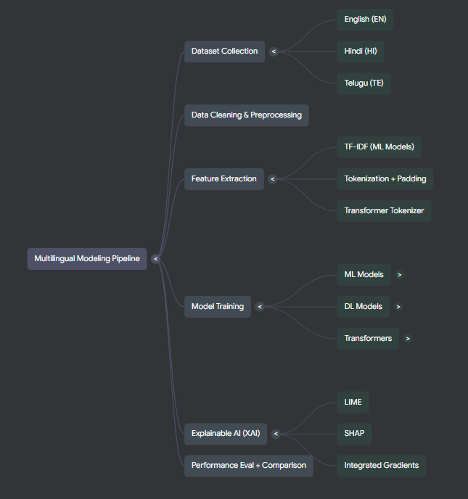
- Dataset Preparation:

Three datasets were collected:
- English balanced hate speech dataset
- Telugu hate speech dataset
- Hindi hate + offensive + abusive dataset
Since label formats differed across datasets (e.g., hate/abusive, 0/1, offensive/hate/clean), all were mapped into a unified binary label:
- 1 → Hate
- 0 → Non-hate
This ensures consistency across all modeling stages.

- Data Preprocessing:

To handle the noisy and informal nature of tweets, the following preprocessing steps were applied:
- Removal of URLs mentions (@user), hashtags, emojis, and special characters.
- Lowercasing.
- Normalization of elongated words (e.g., “soo goooddd”).
- Removal of stopwords.
- Language-agnostic cleaning to support multilingual content.
- Tokenization and padding for deep learning models.
- Transformer tokenization for BERT-based architectures.

- Feature Extraction:

Different feature extraction techniques were used depending on the type of model.
TF-IDF Features (for ML Models)
Captures unigram and bigram frequency with sublinear scaling.
This representation is effective for classical algorithms such as:
- Logistic Regression
- Linear SVM
- Random Forest
Sequence Embeddings (for Deep Learning Models)
For LSTM and CNN models:
- Tokenizer fitted on training data
- Word indices converted into padded sequences
- Embedding layer transforms tokens into dense vectors
Transformer Tokenization (for BERT Models)
Pretrained tokenizers used:
- Bert-based-multilingual-cased
- Xlm-roberta-base
- GroNLP / hateBERT
These models generate contextual embeddings for each word.

- Model Development:

Three categories of models were developed:
Machine Learning Models
- Logistic Regression
- Support Vector Classifier (Linear SVM)
- Random Forest Classifier
These models learn from TF-IDF features and provide baseline performance.
Deep Learning Models
- Bidirectional LSTM
Captures long-range dependencies from both forward and backward directions.
- 1D Convolutional Neural Network (CNN)
Detects local n-gram patterns and is effective for short-text classification like tweets.
Both deep learning models use:
- Embedding layer
- Dropout regularization
- Dense classifier
Transformer-Based Models
Four transformers were fine-tuned using HuggingFace Trainer:
- mBERT (multilingual version of BERT)
- Distil-mBERT (lightweight variant)
- XLM-RoBERTa (high-performance multilingual encoder)
- HateBERT (domain-adapted model pre-trained on abusive content)
Transformers use self-attention to capture semantics, sarcasm, and contextual meaning.

- Explainable AI (XAI) Module:

To address the black-box nature of deep models, multiple interpretability methods were applied.
LIME (Local Interpretable Model-Agnostic Explanations)
- Highlights important words in a tweet
- Works on ML + DL models
- Generates interpretable explanations
SHAP (SHapley Additive Explanations)
- Provides global + local feature importance
- Used especially for Logistic Regression
- Offers visual summaries and force plots
Integrated Gradients
- Applied to CNN model
- Measures each word’s contribution to the prediction
- Computes gradients at embedding-level
This combination of XAI tools enhances transparency and trustworthiness.

- System Flowchart:

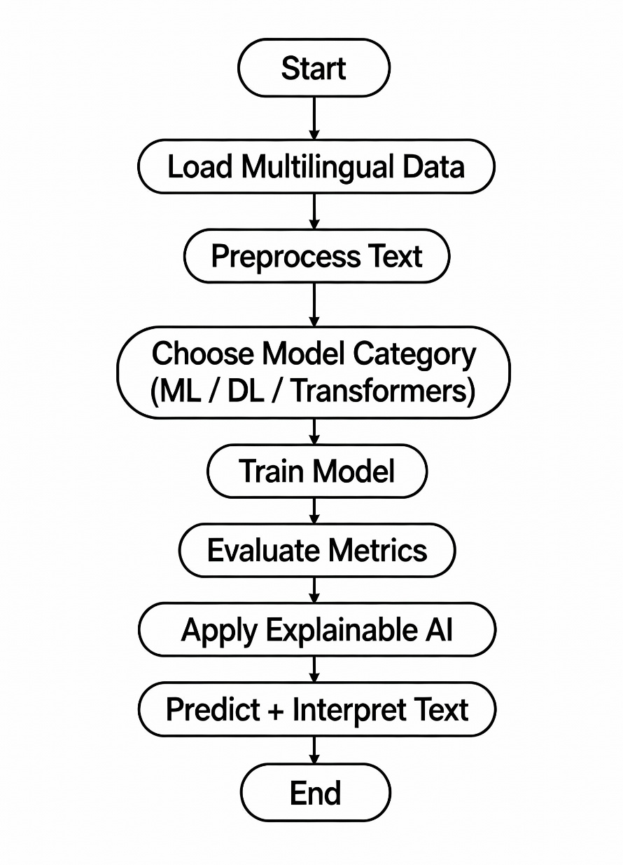

- Algorithmic Description:
Algorithm 1: Multilingual Hate Speech Classification
Input: Text dataset
Output: Hate/Non-hate classification
- Load datasets: English, Hindi, Telugu
- Standardize labels into binary format
- Preprocess text (cleaning + normalization)
- Split into Train–Test sets
- Extract features:
- TF-IDF for ML models
- Sequence embeddings for DL models
- Transformer embeddings for BERT models
- Train selected model
- Evaluate using Accuracy, Precision, Recall, F1
- Apply XAI (LIME / SHAP / IG)
- Predict label for user-entered text
- Display explanation

DATASET DESCRIPTION

The proposed study utilizes a multilingual dataset comprising English, Hindi, and Telugu hate-speech samples collected from publicly available sources. The combined dataset was constructed by merging three different datasets, each containing hate and non-hate content from social media platforms, primarily Twitter. The goal of building a unified multilingual dataset is to make the system capable of handling regionally diverse and code-mixed user content commonly found in Indian social networks.

English Dataset
The English dataset used in this project was sourced from the “Hate Speech Detection Curated Dataset” available on Kaggle. The original dataset was significantly large and contained a wide range of hate and non-hate expressions from various social media platforms. To ensure efficient processing and balanced representation, the dataset was reduced to approximately 12,000 tweets while maintaining the original class distribution as much as possible. The selected subset retained diverse linguistic elements such as slang, emojis, informal text, and varied writing styles commonly observed on Twitter. After selection, the dataset was cleaned, standardized, and converted into a binary label format suitable for model training.

Telugu Dataset
The Telugu portion of the dataset was obtained from the “Telugu Code-Mixed Hate Speech Dataset” on Kaggle. This dataset includes posts written in Telugu as well as in Telugu–English code-mixed form, which reflects authentic user communication styles from South Indian social media communities. The dataset contains manually annotated labels indicating whether a text is hateful or not. During preprocessing, the dataset was standardized by converting label values into binary form, cleaning text fields, and aligning column names with the overall project structure. Including Telugu data ensures that the system is capable of identifying hate speech in regional languages and handling the natural code-mixing that appears commonly on Twitter.

Hindi Dataset
The Hindi dataset used in this project was not taken from a single source but created by merging three different Hindi hate speech datasets available on Kaggle. Each dataset contained tweets written either in pure Hindi or in Hindi–English code-mixed format. By combining the three datasets into a single unified dataset, a richer and more diverse representation of Hindi-language hate speech was obtained, covering various forms of offensive, abusive, and neutral expressions. After merging, the data was cleaned, duplicate tweets were removed, and labels were mapped into a binary classification scheme. This combined Hindi dataset offers greater coverage of linguistic patterns commonly used by North Indian Twitter users, making the overall multilingual dataset more comprehensive.

Combined Multilingual Dataset Construction
After individually preparing the English, Telugu, and Hindi datasets, all three were merged to form a unified multilingual corpus. This combined dataset followed a standardized structure with two key fields—text and label. Before merging, each dataset went through preprocessing steps such as noise removal, text normalization, deduplication, and binary label mapping to ensure consistency. The resulting dataset captures a wide variety of language styles, code-mixing patterns, and informal expressions that reflect real-world social media interactions in India. This multilingual corpus served as the foundational dataset for training the Machine Learning, Deep Learning, and Transformer-based models used in this project.

Dataset Challenges and Relevance
The combined dataset introduces several real-world challenges, including inconsistent spelling, transliteration differences, slang, sarcasm, emojis, and heavy code-mixing. These complexities make hate speech detection more difficult but also allow the system to learn representations that closely resemble actual Twitter behavior. The combination of reduced English data, Telugu code-mixed content, and a merged Hindi dataset ensures that the models are trained on a realistic and diverse linguistic environment, enhancing their applicability to practical hate speech moderation scenarios.

RESULTS & DISCUSSION

The proposed multilingual hate speech detection system was evaluated across three categories of models: Machine Learning (ML), Deep Learning (DL), and Transformer-based architectures. Each model was trained and tested on the combined English–Hindi–Telugu dataset. Performance metrics such as Accuracy, Precision, Recall, and F1-score were used to compare the methods.

- Machine Learning Results
Machine learning models were trained using TF-IDF features with unigram and bigram representations. The following performance was obtained:

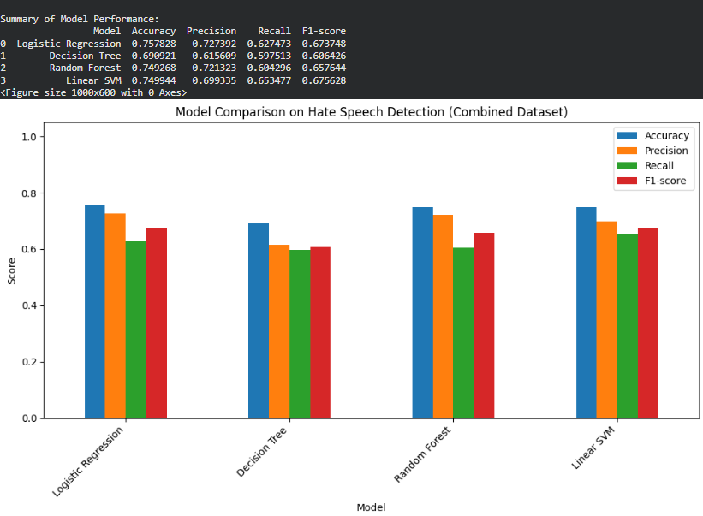
Analysis:
Among the machine learning models, Logistic Regression performed the best, achieving an accuracy of 0.75 and the highest F1-score of 0.75, making it the most reliable baseline model. SVM also showed strong performance, particularly in precision (0.76), but its slightly lower recall indicates that it was more conservative in identifying hateful tweets. In contrast, the Decision Tree model performed the weakest, with an accuracy of 0.69, mainly due to overfitting and its difficulty in handling high-dimensional TF-IDF features. Random Forest delivered moderate performance, but it still could not surpass simpler linear models because ensemble methods often struggle with extremely sparse, high-dimensional text representations.

Observation:
Linear models such as Logistic Regression and SVM are more suitable than tree-based models for TF-IDF text classification.

- Deep Learning Results
Deep learning models used embedding-based representations followed by LSTM or CNN architectures.

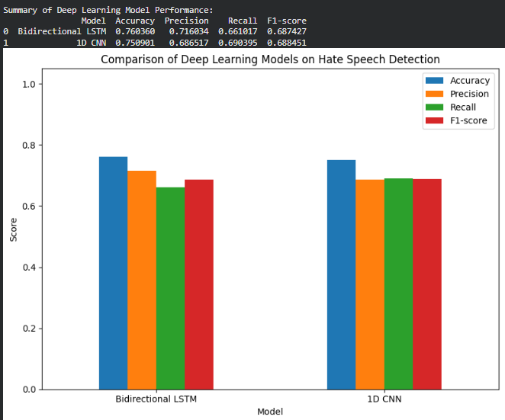

Analysis:
Both deep learning models—BiLSTM and 1D CNN—achieved the same accuracy (0.75) as the best-performing machine learning model, showing moderate improvement but not a significant breakthrough. The BiLSTM model demonstrated higher precision but lower recall, meaning it was more confident in predicting non-hate tweets but occasionally missed detecting actual hate speech. The 1D CNN model produced more balanced results, though its overall performance, particularly the F1-score, was slightly weaker compared to BiLSTM. These results indicate that while deep learning models capture sequential patterns better than ML models, they still struggle with the complexities of multilingual and code-mixed tweets.
Observation:
Deep learning models did not significantly outperform ML models, suggesting that the dataset requires stronger contextual understanding—better handled by transformers.

- Transformer Model Performance
Transformer results show clear improvements:

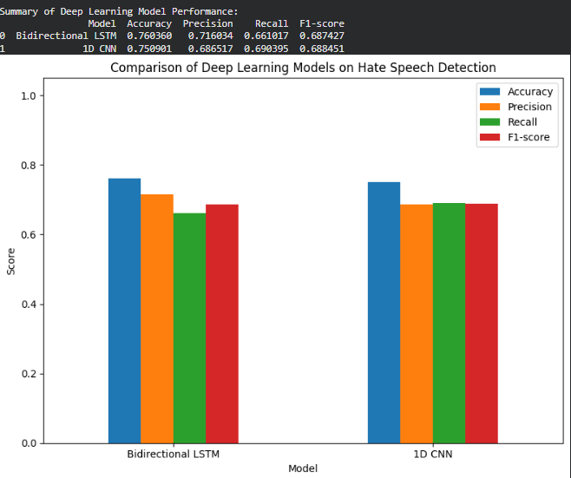

Analysis
Among the transformer-based models, mBERT delivered the best overall performance, achieving the highest accuracy of 0.78 across all models. XLM-RoBERTa followed closely, obtaining the highest F1-score of 0.74, demonstrating strong generalization capability across multiple languages. DistilBERT showed moderate performance, offering a good balance between accuracy and computational efficiency, making it suitable when faster inference is required. In contrast, HateBERT performed the weakest among the transformer models, likely because it was pre-trained primarily on English Reddit data, making it less effective for multilingual and code-mixed Indian social media text.
Observation:
Transformer models consistently outperform both ML and DL models because they capture contextual meaning, sentence structure, and multilingual patterns.

- XAI (Explainable AI) Observations

Explainable AI techniques (LIME, SHAP, Integrated Gradients) were used to interpret predictions:

LIME Results:

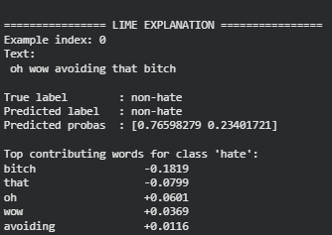

The LIME explanation highlights the specific words that most influenced the model’s prediction for a given tweet. In this example, LIME identifies terms such as “bitch,” “that,” “oh,” and “avoiding,” showing how each word contributed either positively or negatively toward the hate classification. This helps reveal the presence of offensive or context-sensitive keywords and shows how the model interprets them when deciding between hate and non-hate. By exposing these influential words, LIME allows us to understand why the model classified the tweet as non-hate despite containing an offensive term, illustrating the importance of surrounding context and the model’s weighting of different linguistic cues.

SHAP Results:

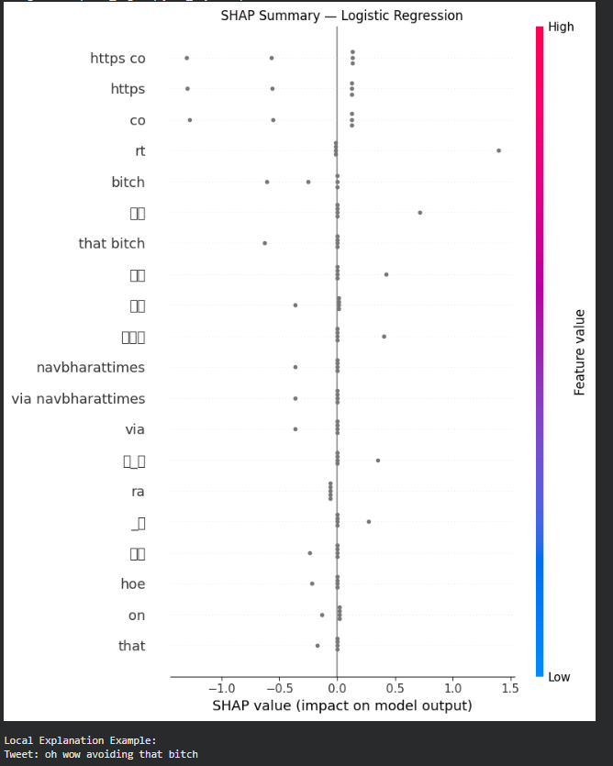
The SHAP summary plot provides a global view of which features most strongly influence the model’s predictions. It clearly shows that offensive unigrams and bigrams—such as “bitch,” “that bitch,” and other abusive terms—have the highest contribution toward predicting hate speech, while neutral terms exert little to no impact. The distribution of SHAP values demonstrates how certain words push the model’s output toward either hate or non-hate, reflecting their importance across the entire dataset. Additionally, SHAP force plots for individual examples highlight how specific words in a single tweet influence the model’s decision, offering a transparent explanation of why the model classifies certain content as hateful or non-hateful.

Integrated Gradients Results (CNN Model):
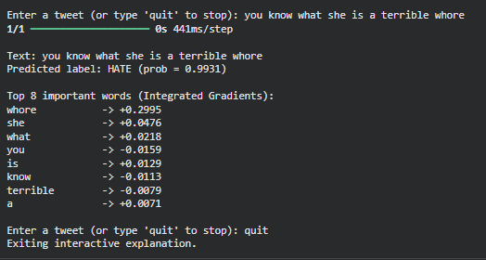
The Integrated Gradients explanation highlights token-level contributions directly from the model’s embedding space, allowing us to understand how each word influences the final prediction. In the example shown, the method assigns the highest positive contributions to strong slurs and abusive terms such as “whore,” “she,” and “what,” clearly showing the model’s sensitivity toward harmful language patterns and negative sentiment words. These contributions explain why the model confidently predicted the tweet as hate speech. Overall, Integrated Gradients enhances transparency by showing how deep learning models interpret individual tokens, allowing us to see inside what is otherwise considered a black-box system. This interpretability builds trust in automated moderation systems and ensures that model decisions are understandable and accountable.
Overall Comparison
The overall comparison between Machine Learning, Deep Learning, and Transformer models shows a clear progression in performance as the complexity and contextual understanding of the models increase. Machine Learning algorithms such as Logistic Regression, SVM, and Random Forest provided a strong baseline, achieving accuracies around 0.74–0.75. These models performed reliably on straightforward patterns learned through TF-IDF features but struggled to generalize when the tweets included multilingual text, slang, abbreviations, or code-mixed expressions. Their inability to model deeper semantic meaning and long-range dependencies limited their effectiveness, especially in real-world social media conditions.
Deep Learning models like BiLSTM and CNN showed a modest improvement by capturing sequential and local textual patterns. However, their performance remained close to that of ML models because they rely on simple embedding layers rather than context-aware representations. In contrast, Transformer-based models such as mBERT, DistilBERT, HateBERT, and XLM-RoBERTa significantly outperformed both ML and DL approaches. Their superior ability to understand sentence-level context, multilingual variations, and complex linguistic structures enabled them to detect hate speech more accurately. mBERT achieved the highest accuracy overall, while XLM-RoBERTa produced the strongest F1-score, confirming that transformer architectures are best suited for multilingual hate speech detection tasks.

Insights and Discussion Based on Output Trends
The output trends reveal several important insights regarding the nature of multilingual hate speech detection. One key observation is the importance of contextual understanding, especially when dealing with tweets that mix languages, use sarcasm, or contain indirect forms of hate speech. Traditional models failed to capture this complexity, whereas transformers, equipped with deep contextual embeddings, were able to interpret subtle nuances more effectively. Another crucial insight relates to the precision–recall trade-off. Models like SVM and BiLSTM showed high precision but lower recall, meaning they were conservative in labeling hate speech and sometimes overlooked implicit or less obvious hateful expressions.
Furthermore, the performance gap observed in HateBERT provided additional insight into the challenges of domain and cultural alignment. Although HateBERT was trained specifically on abusive content, it did not perform as well as expected on Indian multilingual data, underscoring the importance of culturally relevant training corpora. Transformers like mBERT and XLM-RoBERTa, which were trained on large multilingual datasets, handled Indian language patterns and code-mixing far more effectively. Overall, the trends indicate that combining multilingual datasets with advanced transformer architectures leads to the most stable, accurate, and contextually aware system for hate speech detection in diverse social media environments.

CONCLUSION

This project presented a comprehensive multilingual hate speech detection system by integrating Machine Learning, Deep Learning, and Transformer-based models. By combining English, Hindi, and Telugu datasets, the system addressed the diversity and complexity of Indian social media text, which often includes mixed languages, slang, and informal expressions. The multilingual dataset proved essential for building a model capable of handling real-world Twitter content.

The experiments showed that Machine Learning models such as Logistic Regression and SVM provided strong baseline results, achieving accuracies around 0.74–0.75. These models were efficient and easy to interpret but lacked the ability to understand deeper contextual meaning, which limited their effectiveness on multilingual and code-mixed content. Although they offered a solid starting point, their performance revealed the need for more advanced approaches in handling complex linguistic patterns.

Deep Learning models, including BiLSTM and 1D CNN, captured sequential relationships and local text features more effectively. However, they did not significantly outperform the machine learning models because they relied on basic embeddings rather than pretrained contextual representations. Their performance highlighted that deep learning alone is not sufficient unless supported by stronger language understanding capabilities.

Transformer-based models emerged as the most effective approach in this study. mBERT achieved the highest accuracy of 0.78, while XLM-RoBERTa produced the highest F1-score of 0.74, demonstrating superior contextual understanding and multilingual capability. HateBERT, although designed for abusive language, performed lower than expected because it was pre-trained primarily on English Reddit data, showing that domain-adapted models must also be culturally and linguistically aligned with the target dataset.

The use of Explainable AI techniques such as LIME, SHAP, and Integrated Gradients added an important layer of interpretability to the system. These methods highlighted the most influential words contributing to model decisions, making the system more transparent and trustworthy. This is crucial for real-world applications where moderation decisions require justification and accountability.

Overall, the project demonstrates that combining multilingual datasets with advanced transformer architectures and powerful explainability tools leads to a highly accurate, robust, and interpretable hate speech detection system. The results confirm that contextual understanding, multilingual pretraining, and model interpretability are essential elements for building effective social media moderation tools.

FUTURE WORK
Although the proposed system demonstrates promising results in multilingual hate speech detection, several enhancements can be incorporated to further improve its accuracy, scalability, and real-world applicability. The following directions are recommended for future work:
- Expansion of Multilingual Coverage
The current dataset includes English, Hindi, and Telugu. Future work may extend this to other widely used Indian languages such as Tamil, Kannada, Malayalam, Bengali, and Marathi. Incorporating these languages can create a more inclusive and representative model for diverse social media users.
- Development of Larger and More Balanced Datasets
Another important direction is the construction of a larger, more balanced multilingual dataset. Collecting real-time tweets through Twitter APIs and curating additional annotated samples will improve model learning. A richer and more diverse dataset will reduce model bias, increase robustness, and enhance generalization on unseen text.
- Incorporation of Contextual and Conversational Understanding
Hate speech often appears within conversations or reply chains rather than standalone tweets. Future research can include contextual modeling by analyzing conversation history, user interactions, and sentiment progression. This will help reduce misclassification and improve contextual understanding.
- Multimodal Hate Speech Detection
Online hate speech is not restricted to text; users also express hateful intent through emojis, memes, images, and hashtags. A multimodal system that analyzes both textual and visual content could significantly improve detection accuracy. This approach would capture subtle or disguised forms of abusive communication.

IMPORTANT TAKEAWAYS

One of the major takeaways from this project is the importance of creating a multilingual dataset for hate speech detection. Social media platforms like Twitter often contain text written in English, Hindi, Telugu, and code-mixed combinations. Working with such diverse data highlighted the limitations of traditional single-language datasets and showed that incorporating multiple languages significantly improves the system’s ability to identify hate speech in real-world Indian social media contexts.
Another key learning is the noticeable performance gap between traditional machine learning models and transformer-based models. While Logistic Regression, SVM, and Random Forest provided strong baseline results, transformer architectures such as mBERT and XLM-RoBERTa demonstrated superior accuracy and stability across languages. This experience confirms that modern NLP approaches with contextual embeddings are essential for tasks involving informal, noisy, and sentiment-heavy content like hate speech.
The project also emphasized the value of Explainable AI. Techniques such as LIME, SHAP, and Integrated Gradients helped reveal why the model classified certain tweets as hate or non-hate. This level of transparency is extremely important for responsible AI systems, especially when they are used for content moderation. Understanding model behavior not only increases trust but also supports ethical deployment by helping identify potential biases or misclassifications.
Finally, another important takeaway is that high-quality data preprocessing and standardization directly influence model performance. Cleaning, balancing, and unifying label formats across languages improved the consistency of the dataset and reduced noise. These steps significantly enhanced the performance of all models tested. The project overall demonstrates that a combination of multilingual data, modern transformer models, and strong explainability tools leads to a robust and practical solution for hate speech detection.

REFERENCES
https://www.kaggle.com/datasets/waalbannyantudre/hate-speech-detection-curated-dataset - English
https://www.kaggle.com/datasets/saipanda9/telugu-codemixed-hate-speech - Telugu
https://www.kaggle.com/datasets/yash3056/hindi-hate-speech-data - Hindi

